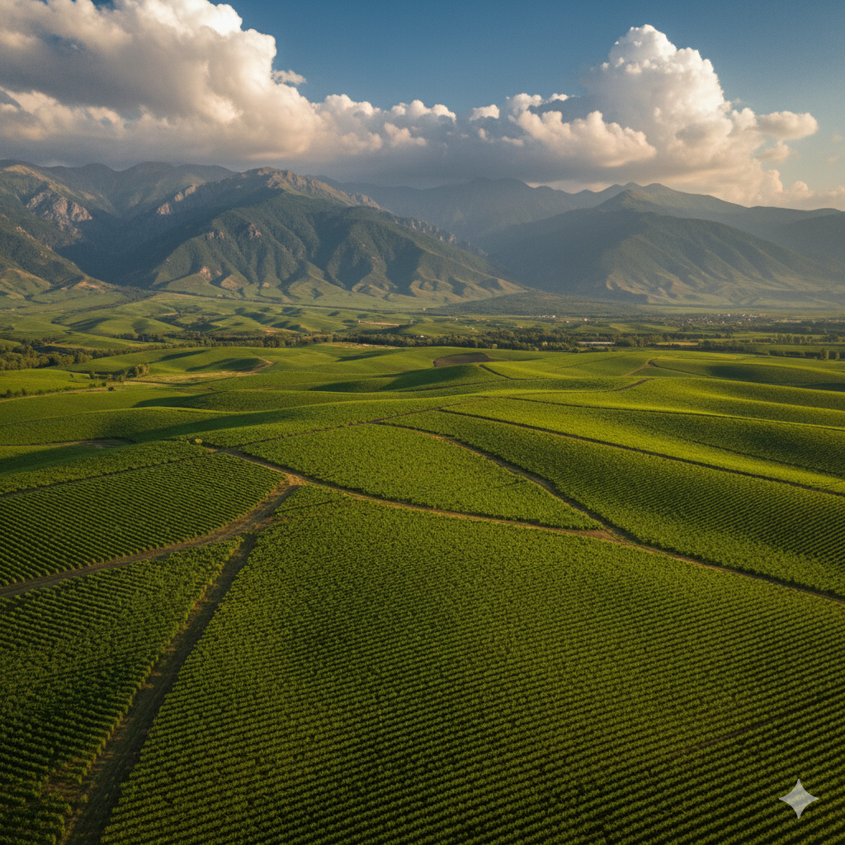

# CHÂTEAU ALAVERDI 1782

Georgia’s winemaking soul — refined for the world.

To bring the soul of Georgian winemaking to the world — one bottle at a time.

For 8,000 years, Georgia has been the cradle of wine. Château Alaverdi 1782 carries this timeless heritage forward with a modern, château-level approach. Named in homage to the restoration year of the sacred Alaverdi Monastery, each bottle expresses the land, the light, and the centuries of devotion that define Georgian wine.  
  
At Château Alaverdi 1782, we unite the spiritual depth of Georgia’s winemaking tradition with the refinement of European craftsmanship. Every drop is a celebration of authenticity, elegance, and soul.

* Vision Statement:

To bring the soul of Georgian winemaking to the world — one bottle at a time. To create a globally recognized Georgian wine brand that honors tradition, delivers exceptional quality, and builds lasting emotional connections with wine lovers everywhere.

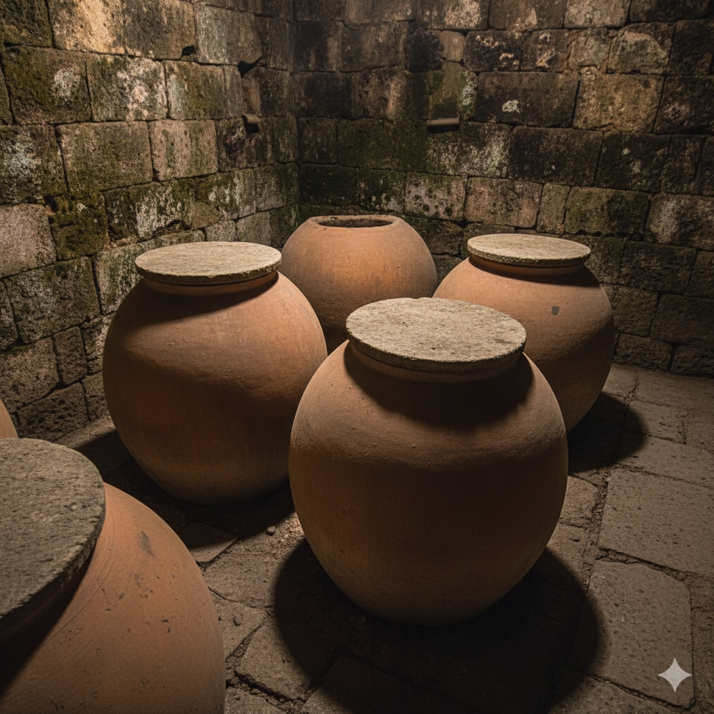

## Our Terroir and Craft

Region: Kakheti, Eastern Georgia — sun-filled valleys, mineral-rich soils, and centuries of winemaking wisdom.  
Vineyards: Hand-harvested grapes from family plots around Alaverdi.  
Method: Blending ancient qvevri fermentation with modern cellar precision.  
Philosophy: Minimal intervention. Maximum expression. True Georgian soul.

## Our Wines

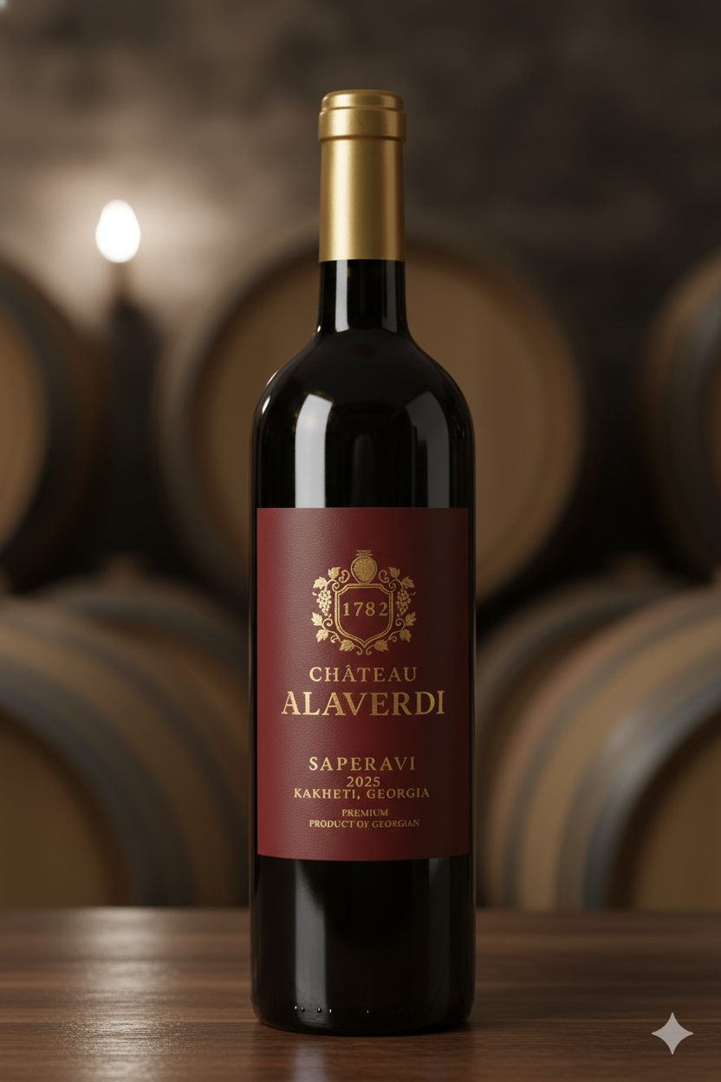

Alaverdi Saperavi 1782 — Reserve Red  
Dry Red Wine | 100% Saperavi | ABV 13.5–14% | Bottle: 750 ml  
Deep ruby-garnet. Aromas of black cherry, plum and graphite. Rich, structured palate with elegant tannin, cedar spice and a long mineral finish. Oak-aged 12–18 months.  
Pairing Suggestions: Roasted lamb, aged cheeses, and dark chocolate desserts.

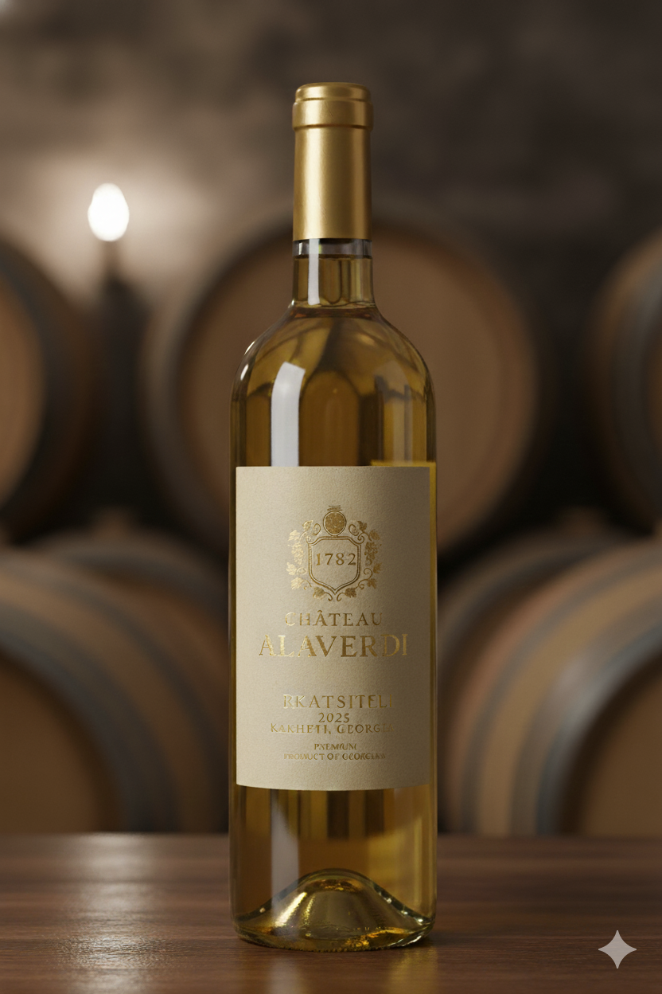

Alaverdi Rkatsiteli 1782 — Classic White  
Dry White Wine | 100% Rkatsiteli | ABV 12.5–13% | Bottle: 750 ml  
Golden amber hue. Fragrant notes of pear, quince, and wild honey. Textured, layered, and elegant with vibrant acidity. Long, savoury finish.  
Pairing Suggestions: Grilled fish, spice-forward vegetable dishes, and light poultry.



Scan to visit our website: https://chateaualaverdi.com



Follow us on WeChat

## Contact & Visits

Château Alaverdi 1782  
Kakheti, Georgia — vineyard visits by appointment  
Email: contact@chateaualaverdi.com  
Website: https://chateaualaverdi.com